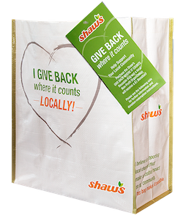



**GIVE BACK WHERE IT COUNTS  
REUSABLE BAG PROGRAM**

Announcement Email

& Social Post

**SUBJECT LINE:** We’ve been selected to partner with the Shaw’s GIVE BACK WHERE IT COUNTS Reusable Bag Program!

**PREVIEW TEXT:** During [*Month*], we receive $1 for every GIVE BACK WHERE IT COUNTS Reusable Bag purchased at our selected Shaw’s location!

Dear [*Staff/Board/Volunteers/Supporters*],

We are excited to share that Shaw’s has selected [*organization*] to benefit from the GIVE BACK WHERE IT COUNTS Reusable Bag Program throughout [*month*]. The Shaw’s GIVE BACK WHERE IT COUNTS Reusable Bag Program makes it easy for shoppers to contribute to their local communities.

Every time a $2.50 reusable GIVE BACK Bag is purchased at the Shaw’s located at [*location*] in [*month*], $1 will be donated to [*organization*]. This is a great way to broaden awareness of our mission and help our cause.

Let’s get started! Share the news with friends and family. Call, send emails, and post on social media. The more people who purchase a GIVE BACK Bag in [*month*], the greater the donation we will receive from Shaw’s!

For more information, please visit [shaws.2givelocal.com](https://shaws.2givelocal.com).

Best,

[*Signature*]



**Share With Your Followers**

**We’re excited that Shaw’s has selected our organization to benefit from the GIVE BACK WHERE IT COUNTS Reusable Bag Program! Throughout [*month*], we will receive a $1 donation for every $2.50 reusable GIVE BACK Bag purchased at the Shaw’s located at [*address of selected store(s)*].**