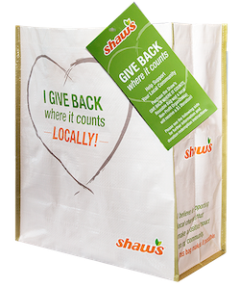

GIVE BACK WHERE IT COUNTS REUSABLE BAG PROGRAM

Sample Press Release

CLICK HERE FOR MARKETING MATERIALS
FOR IMMEDIATE RELEASE: [Name of organization] [Name, phone & email]

[Name of organization] has been selected as April’s Shaw’s GIVE BACK WHERE IT COUNTS
Reusable Bag Program beneficiary.

[City, State] – For the entire month of April, store leadership at Shaw’s [location] location has selected [Name of organization] to receive a $1 donation from every purchase of the $3.00 Shaw’s GIVE BACK WHERE IT COUNTS Reusable Bag.

The GIVE BACK Bag Program facilitates community support with the goal to make a difference in the vicinities where shoppers live and work. More than $300,000 has been donated to over 2,800 local nonprofits since the Program launched in March 2019.

“[1-2 sentence quote reflecting excitement about being chosen],” said [name], Executive Director of [name of organization]. “[Short quote on how this donation will help you fulfill mission].”

[Name of organization] is a nonprofit based in [city, state]. Founded in [year], [name of organization] has [describe efforts in the community]. Learn more about [name of organization] by visiting [website].

For more information on the Shaw’s GIVE BACK Bag Program, visit shaws.2givelocal.com.

shaws.2givelocal.com

