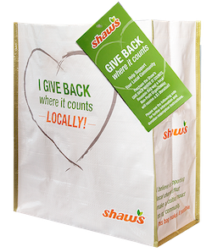

GIVING TAG PROGRAM

Thank Your Supporters Email & Social Post

DOWNLOAD IMAGES

SUBJECT: Thank you! Shaw’s Giving Tag Program

Hello,

Thank you for purchasing a GIVE BACK WHERE IT COUNTS Reusable Bag from Shaw’s and using its attached Giving Tag to direct the $1 donation to [name of your organization]. We’ve raised a total of
$[donation amount] so far!

Whether you’ve bought a bag or helped spread the word, we couldn’t have done this without you. The money generated through this program will help us to [share what you will do with the funds raised].

If you haven’t had a chance to pick up a bag yet, don’t worry! The Shaw’s Giving Tag Program runs all year long. All you have to do is purchase the GIVE BACK WHERE IT COUNTS Reusable Bag at any Shaw’s and follow the instructions on the attached Giving Tag to direct the $1 donation to our organization.

To learn more about this program, please visit shaws.2givelocal.com. Thank you for your continued support!

Share With Your Followers

Thank you! We raised $[donation amount] through the Shaw’s Giving Tag Program! Guess what? You can continue to support us by visiting any Shaw’s, purchasing the GIVE BACK WHERE IT COUNTS Reusable Bag and using the attached Giving Tag to send a $1 donation to us any time throughout the year.

shaws.2givelocal.com

