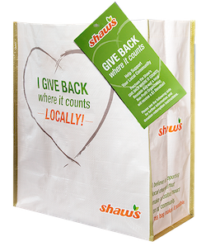
GIVE BACK WHERE IT COUNTS REUSABLE BAG PROGRAM

Sample Email

DOWNLOAD IMAGES

SUBJECT LINE: We’ve been selected by the Shaw’s GIVE BACK WHERE IT COUNTS Reusable Bag Program!
PREVIEW TEXT: For all of [Month] every GIVE BACK WHERE IT COUNTS Reusable Bag purchased at Shaw’s earns us $1!

Dear [Staff/Board/Volunteers],

We are so excited to share that [organization] has been selected to benefit from the Shaw’s GIVE BACK WHERE IT COUNTS Reusable Bag Program, which makes it easy for customers to contribute to their local communities.

For the month of [month], whenever a $3.00 GIVE BACK WHERE IT COUNTS Reusable Bag is purchased at the Shaw’s located at [location], $1 will be donated to [organization]. This is a great way to broaden awareness and help our cause.

Let’s get started! Share the news with friends and family. Call, send emails and post on social media. The more people who purchase the GIVE BACK WHERE IT COUNTS Reusable Bag in [month], the more we can raise!
To learn more about this program, please visit shaws.2givelocal.com.
Best,
[Signature]

shaws.2givelocal.com

